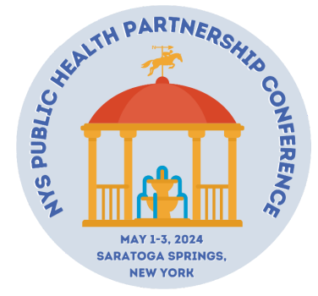

“Building Trust in Public Health to Foster Health Equity”
Call for Abstracts

The New York State Public Health Association (NYSPHA), New York State Association of County Health Officials (NYSACHO) and the New York State Association for Rural Health (NYSARH) invite you to submit a proposal to present at the 2024 NYS Public Health Partnership Conference. The event will be held May 2-3, 2024 at the Hilton & Saratoga Springs City Center in Saratoga, New York. A pre-conference workshop followed by a Welcome Networking & Awards Reception will be held the afternoon/evening of May 1st.

The Public Health Partnership Conference is a one-of-a-kind event in NYS where public health professionals from all settings can engage in public health learning opportunities designed to enhance professional growth and renewal, as well as to provide you with takeaways that will aid in the critical work you to do improve community health outcomes. Presenting at the conference provides an opportunity for you to share your expertise with other public health professionals and early entry career professionals on a variety of current and emerging issues in public health while building a rich networking community. We thank you for your participation and engagement.

Theme
This year’s theme is “Building Trust in Public Health to Foster Health Equity”

Topics* for Presentation
The Public Health Partnership Conference seeks presentations on the topics listed below with suggested areas noted. Presentations are encouraged that address innovative interventions, best practices, and achievements under these topics:

- Innovative Public Health Communication Strategies
- Addressing Health Equity and Health Disparities
- Recruitment and Retention Strategies for Enhancing Public Health Infrastructure
- Supporting Diverse Populations in Communities
- Improving Mental Health and Wellbeing
- Building Public Health Partnerships and Collaborations
- Protecting Against Climate Change and Environmental Health Risks

*Other areas of public health may also be submitted but priority will be given to those meeting the above topic areas.

Abstract Submission Format Options
Presentations that allow participants to leave with replicable skills and that allow interaction with time for Q&A will be prioritized. Submissions that are innovative are also strongly encouraged. The following formats are eligible for submission:

Breakout Session: The presenter(s) will organize the presentation and supporting materials for a captivating session for 15-20 minutes. Presentations will be grouped with 3 others unless otherwise requested. Session length will allow enough time to engage with audience for discussion and Q&A at end.

Poster Presentation: Public health professionals are invited to submit abstracts for poster presentation during one 60-minute session. Poster must be staffed/presented by a minimum of one author during the session. (Note: This is a separate call from the student poster session. There will be a call for student only posters in March 2024.)

Additional Guidelines

Innovative submissions are characterized by, but not limited to, new or creative ideas, cross-sector collaboration, and the dynamic state of change inherent in public health transformation. Presentations will be grouped with others in one session, unless otherwise requested. It is recommended that ONE author deliver the presentation within the 15-20 minute time frame but other presenters may elect to attend to answer questions and assist. Requests for more than 20 minutes may be made on the abstract submission form but space for longer presentations is very limited. All presenters will need to register to attend the conference at the appropriate fee. Authors ONLY attending their session to present may attend at no cost.

Presenters may submit more than one proposal.

Proposal Requirements
The following must be included in the proposal:
- Name of presenter with highest academic degree & institutional affiliation listed.
- Full contact information for each author (address, phone, affiliation, and email).
- Presentation title (short, descriptive).
- Presentation description (no more than 350 words; be detailed so the review committee has as much information as possible to best evaluate your program; address evidence-based methods and how the program promotes attendance).
- Abstract/Program Book Listing (100-125 words; concise and accurate; describe and “sell” the program to conference attendees).
- Three learning objectives written in measurable terms.

Please indicate your preferred presentation format(s). You may select more than one option:
- Break out Session Presentation
- Poster format- displayed/presented during one 60-minute session (Note: This is a separate call from the student poster session. There will be another call for student only posters in March 2024).

How to Submit

All concurrent session proposals must be submitted online via our abstract submission website HERE (https://app.oxfordabstracts.com/stages/6731/submitter).

Submissions must be made by 11:59 PM on October 20, 2023. Submissions sent via email will not be considered.

Timeline

Proposals must be received by 11:59 PM on October 20, 2023. Notification of acceptance or rejection of proposal will be sent to the corresponding author on or by January 20, 2024. Authors may also login (https://app.oxfordabstracts.com/stages/4594/submitter) to view proposal status and reviewer comments.

Conference Registration

All presenters wishing to attend the full conference must register at appropriate registration rate.

Questions

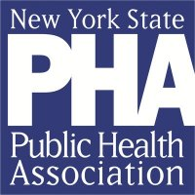
If we can address any questions or assist you in any way, feel free to contact us at info@nyspha.org or (518) 427-5835.
